**Course 609**

**Note on Basic Climate Science**

**1. Earth's annual and global mean energy balance**

Over the long term, the amount of incoming solar radiation absorbed by the Earth and atmosphere is balanced by the Earth and atmosphere releasing the same amount of outgoing longwave radiation. About half of the incoming solar radiation is absorbed by the Earth's surface. This energy is transferred to the atmosphere by warming the air in contact with the surface (thermals), by evapotranspiration and by longwave radiation that is absorbed by clouds and greenhouse gases. The atmosphere in turn radiates longwave energy back to Earth as well as out to space.

*Source:* IPCC AR4, Working Group 1 Main Report, FAQ 1.1, Figure 1.

Available online at <http://www.ipcc.ch/publications_and_data/ar4/wg1/en/faq-1-1.html>

The IPCC document itself gives as its source for this diagram Kiehl and Trenberth (1997).

<http://ipcc.ch/report/graphics/index.php?t=Assessment%20Reports&r=AR5%20-%20WG1>

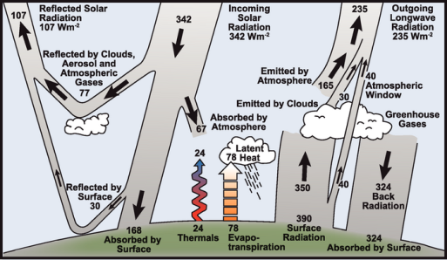

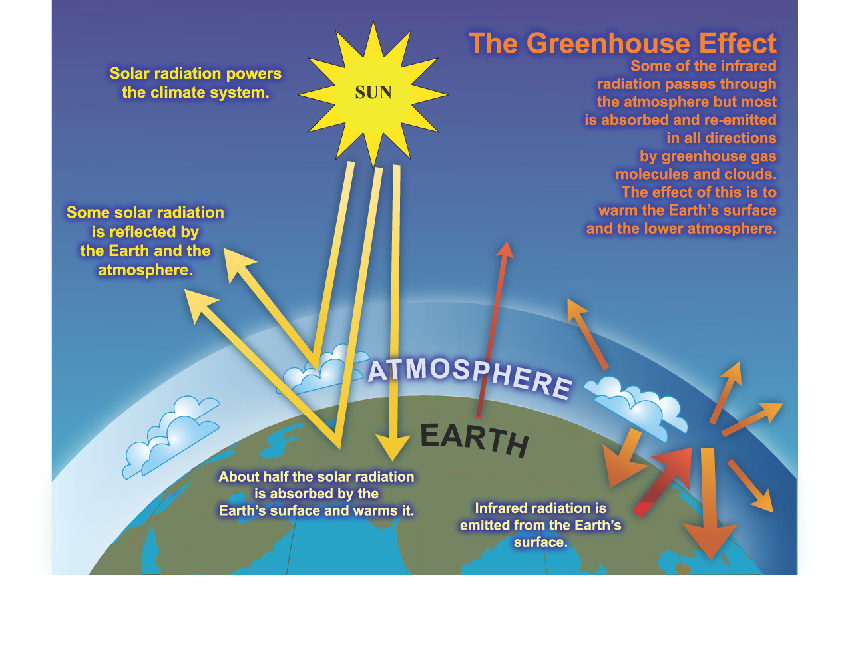

**2. Radiative forcing**

[http://news.mit.edu/2010/explained-radforce-0309#](http://news.mit.edu/2010/explained-radforce-0309)

The concept of radiative forcing is fairly straightforward. Energy is constantly flowing into the atmosphere in the form of sunlight that always shines on half of the Earth’s surface. Some of this sunlight (about 30 percent) is reflected back to space and the rest is absorbed by the planet. And like any warm object sitting in cold surroundings — and space is a very cold place — some energy is always radiating back out into space as invisible infrared light. Subtract the energy flowing out from the energy flowing in, and if the number is anything other than zero, there has to be some warming (or cooling, if the number is negative) going on.

It is as if you have a kettle full of water, which is at room temperature. That means everything is at equilibrium, and nothing will change except as small random variations. But light a fire under that kettle, and suddenly there will be more energy flowing into that water than radiating out, and the water is going to start getting hotter.

In short, radiative forcing is a direct measure of the amount that the Earth’s energy budget is out of balance.

For the Earth’s climate system, it turns out that the level where this imbalance can most meaningfully be measured is the boundary between the troposphere (the lowest level of the atmosphere) and the stratosphere (the very thin upper layer)-- for all practical purposes, where weather and climate are concerned, this boundary marks the top of the atmosphere (aka tropopause). See “layers of the atmosphere” below.

Radiative forcing “was very small in the past, when global average temperatures were not rising or falling substantially,” he explains. For convenience, most researchers choose a “baseline” year before the beginning of world industrialization — usually either 1750 or 1850 — as the zero point, and compute radiative forcing in relation to that base. The IPCC uses 1750 as its base year and it is the changes in the various radiative forcing agents since then that are counted.

So, given all these factors and their range of errors, what’s the answer? The current level of radiative forcing, according to the IPCC AR4, is 1.6 watts per square meter (with a range of uncertainty from 0.6 to 2.4). That may not sound like much, Prinn says, until you consider the total land area of the Earth and multiply it out, which gives a total warming effect of about 800 terawatts — more than 50 times the world’s average rate of energy consumption, which is currently about 15 terawatts.

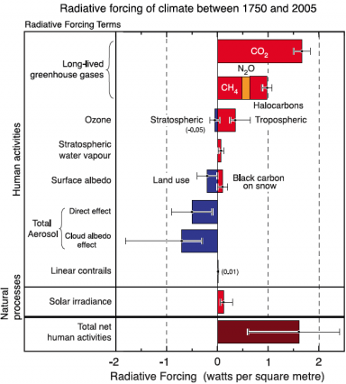

**3. Climate sensitivity**

<http://news.mit.edu/2010/explained-climate-sensitivity>

Specifically, the term is defined as how much the average global surface temperature will increase if there is a doubling of greenhouse gases (expressed as carbon dioxide equivalents) in the air, once the planet has had a chance to settle into a new equilibrium after the increase occurs. In other words, it’s a direct measure of how the Earth’s climate will respond to that doubling.

It is important to note that climate sensitivity is figured on the basis of an overall doubling, compared to pre-industrial levels, of carbon dioxide and other greenhouse gases. But the temperature change given by this definition of climate sensitivity is only part of the story. The actual increase might be greater in the long run because greenhouse gas levels in the atmosphere could more than double without strong policies to control emissions. But in the short run, the actual warming could be less than suggested by the climate sensitivity, since due to the thermal inertia of the ocean, it may take some time after a doubling of the concentration is reached before the climate reaches a new equilibrium.

<https://en.wikipedia.org/wiki/Climate_sensitivity>

**Climate sensitivity** is the equilibrium temperature change in response to changes of the [radiative forcing](https://en.wikipedia.org/wiki/Radiative_forcing).

\Delta T_s = \lambda \cdot RF

The **equilibrium climate sensitivity** (ECS) refers to the equilibrium change in global mean near-surface air temperature that would result from a sustained doubling of the atmospheric (equivalent) carbon dioxide concentration (ΔTx2). As estimated by the IPCC Fifth Assessment Report (*AR5*) "there is *high confidence* that ECS is *extremely unlikely* less than 1°C and *medium confidence* that the ECS is *likely* (i.e., probability is between 66-90%) between 1.5°C and 4.5°C and *very unlikely* greater than 6°C."

CO2 climate sensitivity has a component directly due to radiative forcing by CO2, and a further contribution arising from [climate feedbacks](https://en.wikipedia.org/wiki/Climate_change_feedback), both positive and negative. "Without any feedbacks, a **doubling of CO2 (which amounts to a forcing of 3.7 W/m2)** would result in 1 °C global warming, which is easy to calculate and is undisputed. The remaining uncertainty is due entirely to feedbacks in the system, namely, the water vapor feedback, the ice-albedo feedback, the cloud feedback, and the lapse rate feedback", addition of these feedbacks leads to a value of the sensitivity to CO2 doubling of approximately 3 °C ± 1.5 °C, **which corresponds to a value of λ of 0.8 K/(W/m2)**.

<https://en.wikipedia.org/wiki/Svante_Arrhenius>

In its original form, Arrhenius' greenhouse law reads as follows:

*“if the quantity of carbonic acid [CO2] increases in geometric progression, the augmentation of the temperature will increase nearly in arithmetic progression.”*

The following equivalent formulation of Arrhenius' greenhouse law is still used today:

\Delta F = \alpha \ln(C/C_0)

Here *C* is carbon dioxide (CO2) concentration measured in [parts per](https://en.wikipedia.org/wiki/Parts-per_notation) million by volume (ppmv); *C*0 denotes a baseline or unperturbed concentration of CO2, and ΔF is the [radiative forcing](https://en.wikipedia.org/wiki/Radiative_forcing), measured in [watts](https://en.wikipedia.org/wiki/Watt) per square [meter](https://en.wikipedia.org/wiki/Meter). The constant alpha (α) has been assigned a value between five and seven.

<http://www.skepticalscience.com/C02-emissions-vs-Temperature-growth.html>

The relationship between atmospheric CO2 concentration and the corresponding increase in radiative forcing is given ([3rd Report IPCC – TAR, table 6.2](http://www.grida.no/climate/ipcc_tar/wg1/pdf/tar-06.pdf)) by the logarithmic formula: **RF = 5.35·ln (C/C0)**, where RF denotes radiative forcing in W/m2, C is CO2 concentration in parts per million (ppm), C0 is a reference concentration (usually the latter is 280 ppm – the concentration before the industrial revolution).

Doubling the CO2 concentration (which is equivalent to 3.7 W/m2 increase in radiative forcing) causes temperature increase of approx. 3°C.

<http://www.skepticalscience.com/climate-sensitivity-basic.htm>

<http://www.grida.no/climate/ipcc_tar/wg1/pdf/tar-06.pdf>

Chapter 6, IPCC 3rd Assessment Report (p. 354):

“The **climate sensitivity parameter (global mean surface temperature response ΔTs to the radiative forcing ΔF)** is defined as”:

**ΔTs / ΔF = λ**

Chapter 6, IPCC 3rd Assessment Report (p. 358)

[Note the figure of 5.35 in last column]



**4. Climate feedback**

<https://en.wikipedia.org/wiki/Climate_change_feedback>

Climate change feedback is important in the understanding of global warming because feedback processes may amplify or diminish the effect of each [climate forcing](https://en.wikipedia.org/wiki/Climate_forcing), and soplay an important part in determining the [climate sensitivity](https://en.wikipedia.org/wiki/Climate_sensitivity) and future climate state. [Feedback](https://en.wikipedia.org/wiki/Feedback) in general is the process in which changing one quantity changes a second quantity, and the change in the second quantity in turn changes the first. Positive feedback amplifies the change in the first quantity while negative feedback reduces it.

The term "forcing" means a change which may "push" the climate system in the direction of warming or cooling. An example of a climate forcing is increased atmospheric concentrations of greenhouse gases. By definition, forcings are external to the climate system while feedbacks are internal; in essence, feedbacks represent the internal processes of the system. Some feedbacks may act in relative isolation to the rest of the climate system; others may be tightly coupled; hence it may be difficult to tell just how much a particular process contributes. Forcings, feedbacks and the dynamics of the climate system determine how much and how fast the climate changes. The main **positive feedback** in global warming is the tendency of warming to increase the amount of water vapor in the atmosphere, which in turn leads to further warming. The main **negative feedback** comes from the Stefan–Boltzmann law, the amount of heat radiated from the Earth into space changes with the fourth power of the temperature of Earth's surface and atmosphere.

**5. Layers of the atmosphere**

<http://www.skepticalscience.com/print.php?r=136>

For purposes of climate change only the troposphere is relevant (that is, up to tropopause, the boundary between troposphere and stratosphere. Note the different temperatures (red line on right in second figure below) – cools then warms then cools again as you go higher.

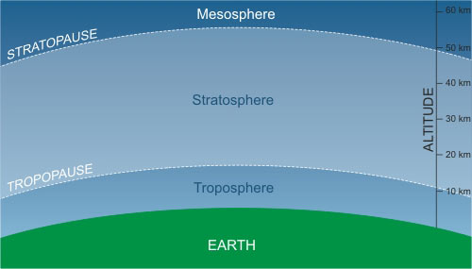

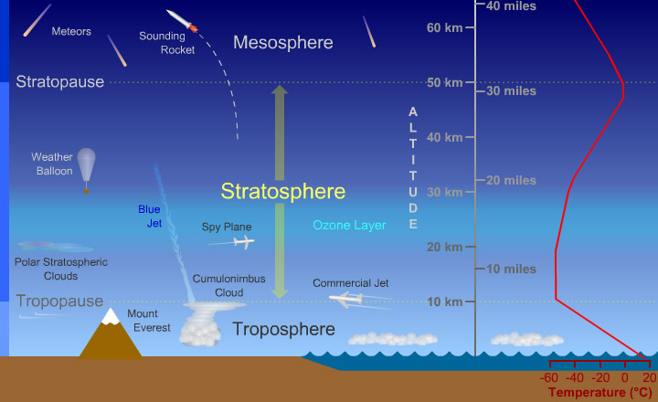

**6. CO2 concentrations and CO2 budget**

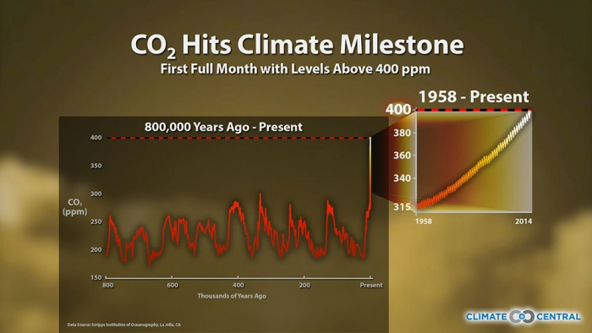

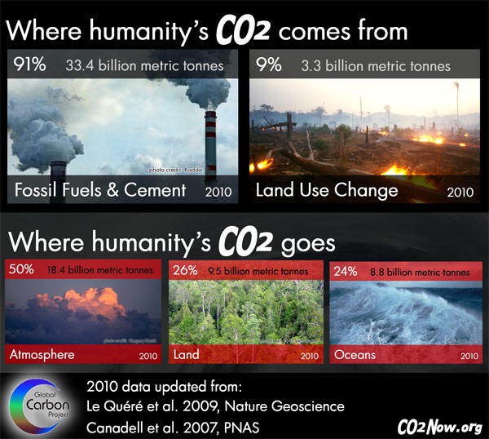

Times of India (September 22, 2013)

